Blinkit Analysis
- See all the imported Data:
SELECT * FROM blinkit_data
- DATA CLEANING:
Cleaning the Item_Fat_Content field ensures data consistency and accuracy in analysis. The presence of multiple variations of the same category (e.g., LF, low fat vs. Low Fat) can cause issues in reporting, aggregations, and filtering. By standardizing these values, we improve data quality, making it easier to generate insights and maintain uniformity in our datasets.
UPDATE blinkit_data
SET Item_Fat_Content =
CASE
WHEN Item_Fat_Content IN ('LF', 'low fat') THEN 'Low Fat'
WHEN Item_Fat_Content = 'reg' THEN 'Regular'
ELSE Item_Fat_Content
END;
- After executing this query check the data has been cleaned or not using below query
SELECT DISTINCT Item_Fat_Content FROM blinkit_data;

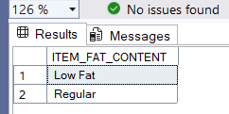

A. KPI’s
1. TOTAL SALES:
SELECT CAST(SUM(Sales) / 1000000.0 AS DECIMAL(10,2)) AS Total_Sales_Million
FROM blinkit_data;
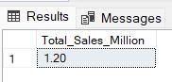
2. AVERAGE SALES
SELECT CAST(AVG(Sales) AS INT) AS Avg_Sales
FROM blinkit_data;
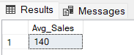
3. NO OF ITEMS
SELECT COUNT(*) AS No_of_Orders
FROM blinkit_data;
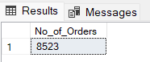
4. AVG RATING
SELECT CAST(AVG(Rating) AS DECIMAL(10,1)) AS Avg_Rating
FROM blinkit_data;
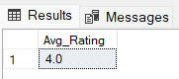

- TOTAL SALES BY FAT CONTENT:
Purpose:
This query analyzes sales performance based on item fat content.
Explanation:
- Groups data by ITEM_FAT_CONTENT (e.g., Low Fat, Regular).
- Calculates:
  - Total sales
  - Average sales
  - Number of items sold
  - Average customer rating
- Helps compare how different fat categories perform in sales and customer satisfaction.

SQL Query:
SELECT ITEM_FAT_CONTENT,
CAST(SUM(SALES) AS DECIMAL (10,2)) AS TOTAL_SALES,
CAST(AVG(SALES) AS DECIMAL(10,1)) AS AVG_SALES,
COUNT(*) AS NO_OF_ITEM,
CAST(AVG(RATING) AS DECIMAL(10,2)) AS AVG_RATING
FROM blinkit_data
GROUP BY ITEM_FAT_CONTENT
OUTPUT:
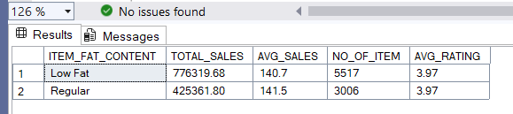

- TOTAL SALES BY ITEM TYPE:
Purpose:
To identify the best-selling product categories.
Explanation:
- Groups data by Item_Type.
- Calculates total and average sales, item count, and average rating.
- Sorts item types by total sales in descending order.

SQL Query:
SELECT Item_Type,
CAST(SUM(SALES) AS DECIMAL (10,2)) AS TOTAL_SALES,
CAST(AVG(SALES) AS DECIMAL(10,1)) AS AVG_SALES,
COUNT(*) AS NO_OF_ITEM,
CAST(AVG(RATING) AS DECIMAL(10,2)) AS AVG_RATING
FROM blinkit_data
GROUP BY Item_Type
ORDER BY Total_Sales DESC
OUTPUT:
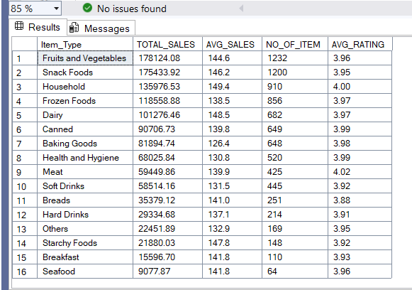
- FAT CONTENT BY OUTLET FOR TOTAL SALES
Purpose:
To compare Low Fat and Regular item sales across outlet locations.
Explanation:
- Aggregates sales by outlet location and fat content.
- Uses a PIVOT to convert fat content values into columns.
- Displays total sales of Low Fat and Regular items for each location type.
- Makes comparison easier across locations.
SQL Query:
SELECT Outlet_Location_Type,
ISNULL([Low Fat], 0) AS Low_Fat,
ISNULL([Regular], 0) AS Regular
FROM
(
SELECT Outlet_Location_Type, Item_Fat_Content,
CAST (SUM(Sales) AS DECIMAL (10,2)) AS Total_Sales
FROM blinkit_data
GROUP BY Outlet_Location_Type, Item_Fat_Content
) AS SourceTable
PIVOT
(
SUM(Total_Sales)
FOR Item_Fat_Content IN ([Low Fat], [Regular])
) AS PivotTable
ORDER BY Outlet_Location_Type
OUTPUT:
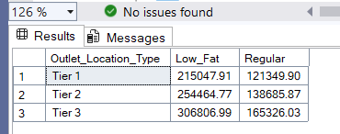

- TOTAL SALES BY OUTLET ESTABLISHMENT
Purpose:
To analyze how outlet age affects sales performance.
Explanation:
- Groups outlets by their establishment year.
- Calculates total sales, average sales, number of items, and average rating.
- Orders results chronologically to show trends over time.

SQL Query:
SELECT Outlet_Establishment_Year,
CAST(SUM(Sales) AS DECIMAL(10,2)) AS Total_Sales,
CAST(AVG(SALES) AS DECIMAL(10,1)) AS AVG_SALES,
COUNT(*) AS NO_OF_ITEM,
CAST(AVG(RATING) AS DECIMAL(10,2)) AS AVG_RATING
FROM blinkit_data
GROUP BY Outlet_Establishment_Year
ORDER BY Outlet_Establishment_Year

OUTPUT:
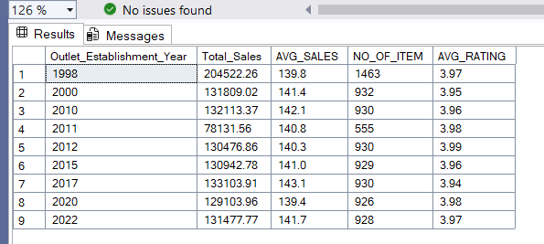

- PERCENTAGE OF SALES BY OUTLET SIZE
Purpose:
To measure how much each outlet size contributes to total sales.
Explanation:
- Groups data by Outlet_Size.
- Calculates total sales and each size’s percentage contribution to overall sales.
- Also includes average sales, item count, and ratings.
- Useful for understanding which outlet size drives the most revenue.
SQL Query:
SELECT Outlet_Size,
CAST(SUM(Sales) AS DECIMAL(10,2)) AS Total_Sales,
CAST((SUM(Sales) * 100.0 / SUM(SUM(Sales)) OVER()) AS DECIMAL(10,0)) AS Sales_Percentage,
CAST(AVG(SALES) AS DECIMAL(10,1)) AS AVG_SALES,
COUNT(*) AS NO_OF_ITEM,
CAST(AVG(RATING) AS DECIMAL(10,2)) AS AVG_RATING
FROM blinkit_data
GROUP BY Outlet_Size
ORDER BY Total_Sales DESC
OUTPUT:
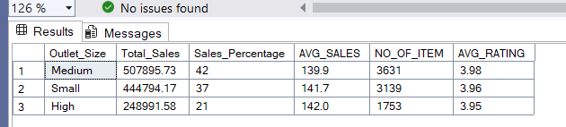

- SALES BY OUTLET LOCATION
Purpose:
To compare sales performance across different outlet locations.
Explanation:
- Groups data by Outlet_Location_Type.
- Calculates total sales and percentage contribution of each location.
- Helps identify high-performing and low-performing regions.
SQL Query:
SELECT Outlet_Location_Type,
CAST(SUM(Sales) AS DECIMAL(10,2)) AS Total_Sales,
CAST((SUM(Sales) * 100.0 / SUM(SUM(Sales)) OVER()) AS DECIMAL(10,0)) AS Sales_Percentage,
CAST(AVG(SALES) AS DECIMAL(10,1)) AS AVG_SALES,
COUNT(*) AS NO_OF_ITEM,
CAST(AVG(RATING) AS DECIMAL(10,2)) AS AVG_RATING
FROM blinkit_data
GROUP BY Outlet_Location_Type
ORDER BY Total_Sales DESC
OUTPUT:
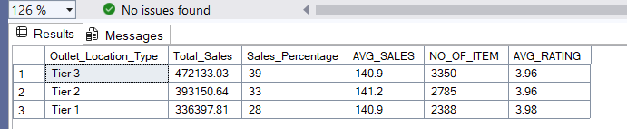

- ALL METRICS BY OUTLET TYPE:
Purpose:
To evaluate overall outlet performance.
Explanation:
- Groups data by Outlet_Type.
- Calculates:
  - Total sales
  - Average sales
  - Number of items sold
  - Average rating
  - Average item visibility
- Uses RANK() to rank outlet types based on total sales.
SQL Query:
SELECT Outlet_Type,
CAST(SUM(Sales) AS DECIMAL(10,2)) AS Total_Sales,
CAST(AVG(Sales) AS DECIMAL(10,0)) AS Avg_Sales,
COUNT(*) AS No_Of_Items,
CAST(AVG(Rating) AS DECIMAL(10,2)) AS Avg_Rating,
CAST(AVG(Item_Visibility) AS DECIMAL(10,2)) AS Item_Visibility,
RANK() OVER (ORDER BY SUM(Sales) DESC) AS Sales_Rank
FROM blinkit_data
GROUP BY Outlet_Type
ORDER BY Total_Sales DESC
OUTPUT:
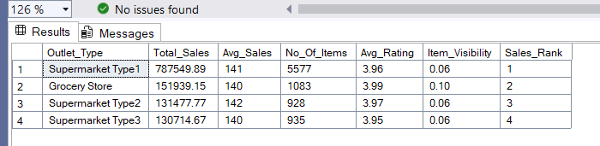

- Total Sales by Item Visibility
Purpose:
To understand the impact of product visibility on sales.
Explanation:
- Categorizes item visibility into:
  - Low
  - Medium
  - High
- Groups sales by these visibility levels.
- Shows which visibility range generates the highest revenue.

SQL Query:
SELECT
CASE
WHEN Item_Visibility < 0.05 THEN 'Low Visibility'
WHEN Item_Visibility BETWEEN 0.05 AND 0.15 THEN 'Medium Visibility'
ELSE 'High Visibility'
END AS Visibility_Level,
CAST(SUM(Sales) AS DECIMAL(10,2)) AS Total_Sales
FROM blinkit_data
GROUP BY
CASE
WHEN Item_Visibility < 0.05 THEN 'Low Visibility'
WHEN Item_Visibility BETWEEN 0.05 AND 0.15 THEN 'Medium Visibility'
ELSE 'High Visibility'
END
ORDER BY Total_Sales DESC
OUTPUT:
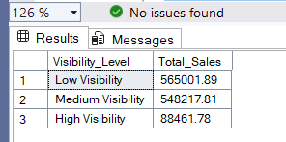

- Outlet Sales Above Location Average
Purpose:
To identify high-performing outlets within each location.
Explanation:
- Calculates total sales for each outlet type within a location.
- Filters outlets whose total sales exceed the average sales of that location.
- Helps identify strong performers relative to their surroundings.

SQL Query:
SELECT
Outlet_Location_Type,
Outlet_Type,
CAST(SUM(Sales) AS DECIMAL(10,2)) AS Total_Sales
FROM blinkit_data b
GROUP BY Outlet_Location_Type, Outlet_Type
HAVING SUM(Sales) >
(
SELECT AVG(Sales)
FROM blinkit_data
WHERE Outlet_Location_Type = b.Outlet_Location_Type
)
OUTPUT:
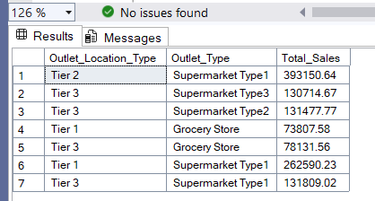

10 . Top Outlet Type Performance by Location
Purpose:
To find the best outlet type in each location category.
Explanation:
- Uses RANK() to rank outlet types by total sales within each location.
- Returns only the top-ranked outlet type per location.
- Useful for strategic outlet planning.
SQL Query:
SELECT * FROM (
SELECT
Outlet_Location_Type,
Outlet_Type,
CAST(SUM(Sales) AS DECIMAL(10,2)) AS Total_Sales,
RANK() OVER (
PARTITION BY Outlet_Location_Type
ORDER BY SUM(Sales) DESC
) AS Rank
FROM blinkit_data
GROUP BY Outlet_Location_Type, Outlet_Type
) t
WHERE Rank = 1
OUTPUT:
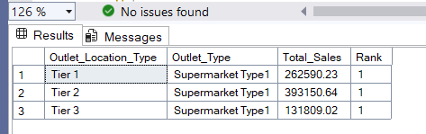

- Type Contribution Analysis
Purpose:
To analyze how each item type contributes to sales within an outlet type.
Explanation:
- Groups data by outlet type and item type.
- Calculates total sales per item type.
- Computes the percentage contribution of each item type within its outlet category.

SQL Query:

SELECT Outlet_Type, Item_Type,
CAST(SUM(Sales) AS DECIMAL(10,2)) AS Item_Sales,
CAST(SUM(Sales) * 100.0 /SUM(SUM(Sales)) OVER (PARTITION BY Outlet_Type)
AS DECIMAL(10,2)) AS Contribution_Percentage
FROM blinkit_data
GROUP BY Outlet_Type, Item_Type
OUTPUT:
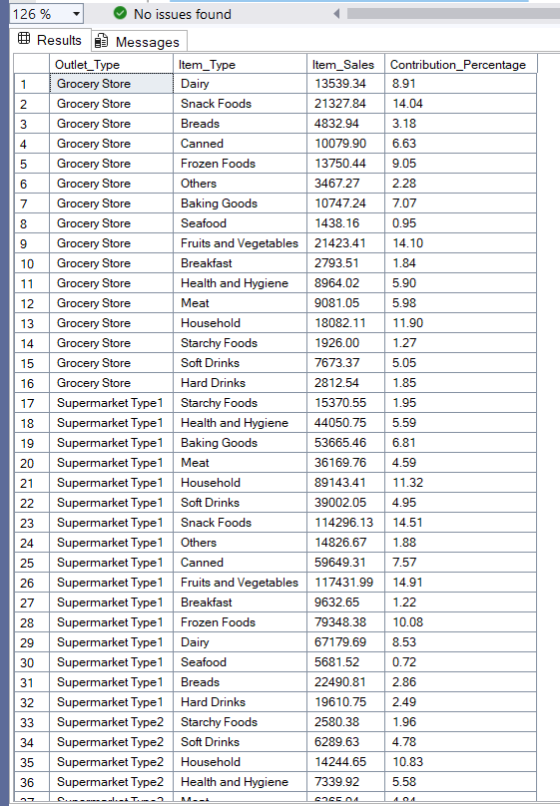
- Sales Across Outlet Types
Purpose:
To compare fat content preferences across outlet types.
Explanation:
- Groups sales by outlet type and item fat content.
- Calculates total sales for Low Fat and Regular items.
- Helps understand product demand patterns across outlet formats.

SQL Query:
SELECT
Outlet_Type,
Item_Fat_Content,
CAST(SUM(Sales) AS DECIMAL(10,2)) AS Total_Sales
FROM blinkit_data
GROUP BY Outlet_Type, Item_Fat_Content
ORDER BY Outlet_Type, Total_Sales DESC

OUTPUT:
